18th Sunday after Pentecost September 27, 2026

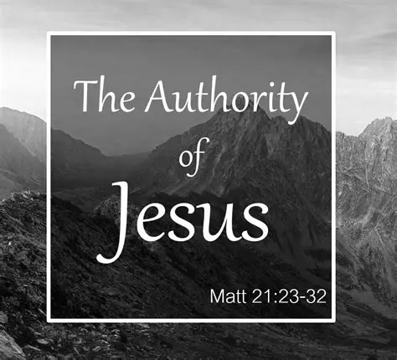

First Lutheran Church
208 West Sandusky Avenue
Bellefontaine, Ohio
(937) 592-7699
Pastor Lawrence J. Novak www.flcbellefontaine.org

Mission Statement:
Sharing God’s grace through prayer, witness, and service.

Vision Statement:
Connecting people to Jesus and one another

WELCOME to our worship service this morning, especially our visitors.
Our Welcome Statement

At First Lutheran, all means all, and the gifts of God are free. We welcome, love, affirm, and include everyone in our faith community regardless of race, ethnicity, sexual orientation, or gender identity.

Here in this place, you will find a warm, loving Christian family which strives to faithfully proclaim the Good News of Jesus Christ to all of God’s children. We renounce racism, discrimination, and persecution in any form, in faithfulness to the gospel, and to the best of our ability, we promise to provide ministries and pastoral care to all who seek God in this place.
GOD WELCOMES ALL, AND SO DO WE.
This service is being recorded.

Please listen to the worship assistant for prayer concerns.

The altar flowers are given by Jinny Fergus in honor of Tina, Jordan, Megan, and Olivia’s birthday & Beth Harmon to the glory of God.

Remember those of our congregation in a care facility:

Logan Acres Care: Margie Anderson – Room #202

Green Hills of West Liberty: Tom Secrist- Inn #10
John Gensemer – Inn #9

Urbana Health and Rehabilitation Center: Mike Myers, Rm. A24
741 East Water
Urbana, OH 43078

Sycamore Springs Nursing & Rehabilitation: Lowell Huber
2164 E. Central Ave.
Room 1404L
Miamisburg, OH 45342
(937)-560-093
18th Sunday after Pentecost
September 27, 2026
10:00 AM

ANNOUNCEMENTS

+ + + WE ENTER INTO WORSHIP + + +

Prelude “Lord, Take My Heart” by Overholt

Please Stand

Confession and Forgiveness

P: Blessed be the holy Trinity, ☩ one God,
who pours love into our hearts
and healing upon the earth.
C: Amen.

P: Confident that God justifies us by grace through faith,
let us confess our sin.

Pause for silence and reflection.

P: Compassionate God,

C: we confess that we struggle to embody your goodness
in the world and in our own hearts.
Creation groans from overuse.
Jealousy and bitterness strain our relationships.
Indifference keeps us from seeking justice.
Divisions disrupt your call to show genuine love
to others.

Turn our hearts back to you.
Restore our world and reconcile us to one another.
Renew us to live as your holy people,
following the way of Jesus Christ.
Amen.

P: Hear this good news:
We have peace with God through ☩ Jesus Christ,
in whom there is no condemnation,
but only forgiveness and the promise of eternal life.
Receive freely this healing gift of grace.
C: Amen.

Gathering Hymn ACS #1084 “God, Be the Love to Search and Keep Me” insert

Greeting

P: The grace of our Lord Jesus Christ, the love of God, and the communion of the Holy Spirit be with you all.
C: And also with you.

Kyrie
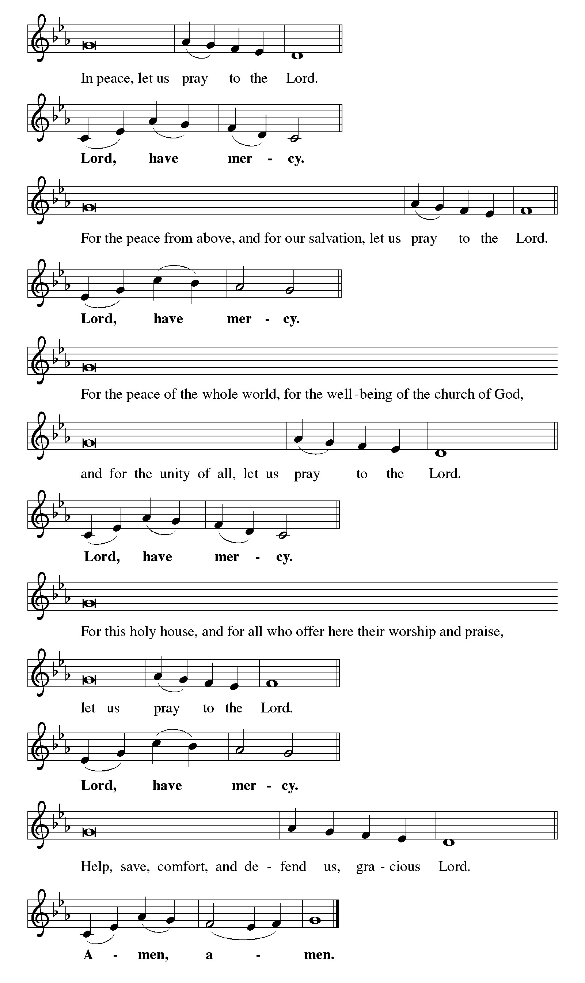
Canticle of Praise This is the Feast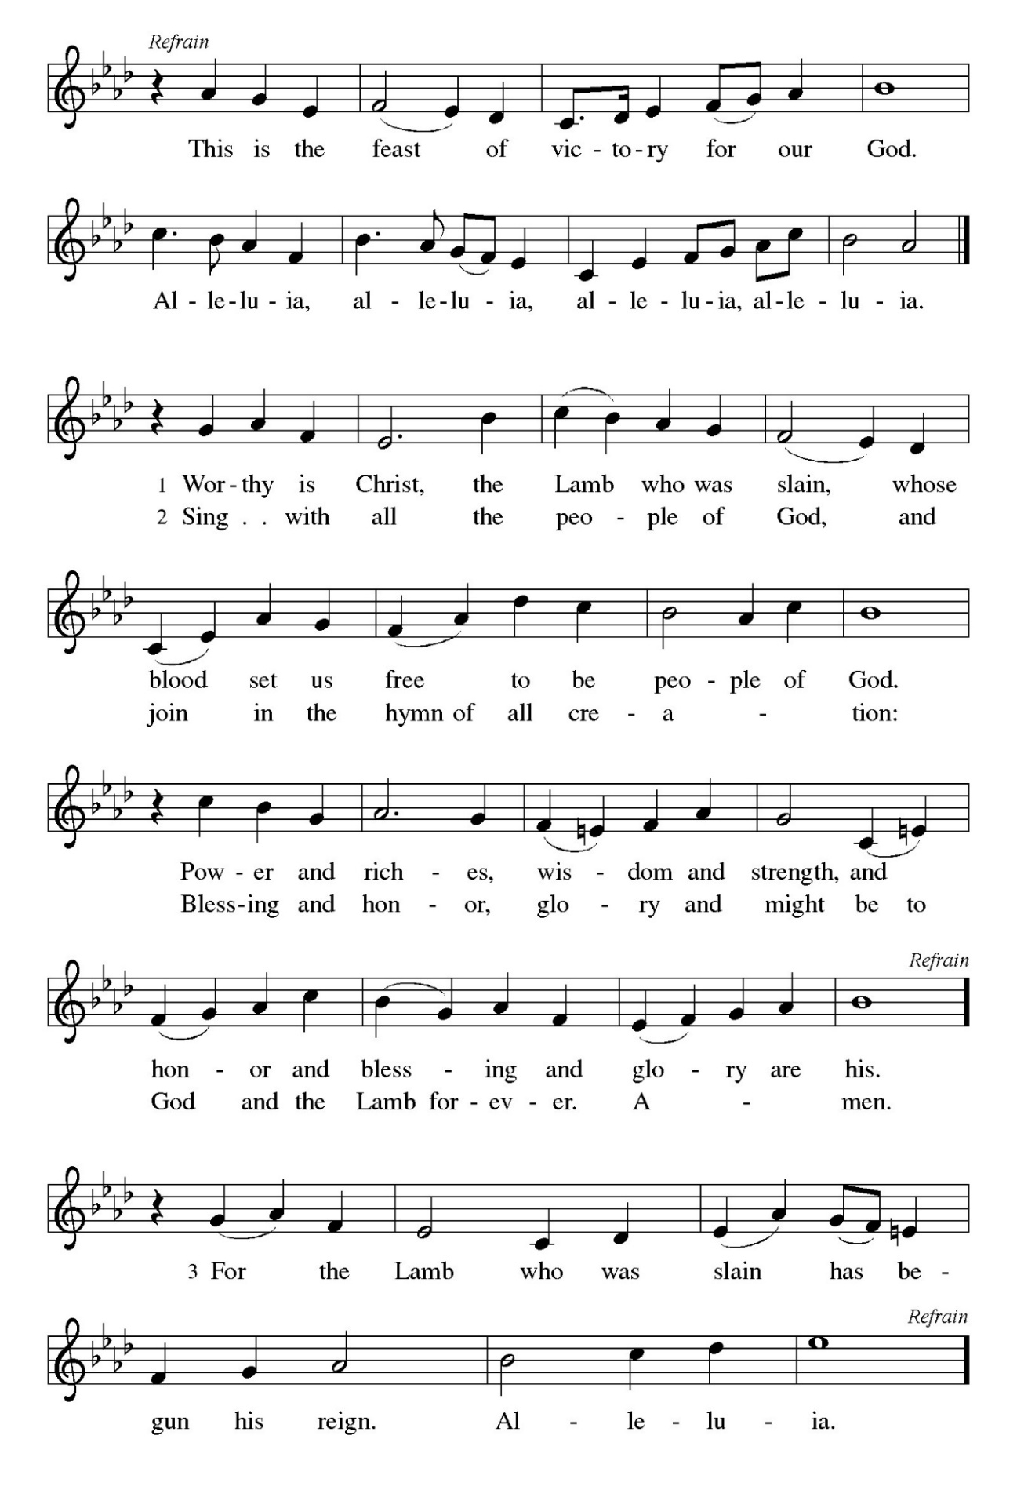

Prayer of the Day
P: The Lord be with you.
C: And also with you.

Prayer of the Day

P: Let us pray together the prayer of the day. God of love, giver of life,
C: you know our frailties and failings. Give us your grace to overcome them, keep us from those things that harm us, and guide us in the way of salvation, through Jesus Christ, our Savior and Lord.
Amen.

Please Be Seated

+ + + THE WORD PROCLAIMED + +

Anthem “You Are the Light That I Seek”

The First Reading is from Exodus 17:1-7

¹ From the wilderness of Sin the whole congregation of the Israelites journeyed by stages, as the Lord commanded. They camped at Rephidim, but there was no water for the people to drink. ² The people quarreled with Moses and said, “Give us water to drink.” Moses said to them, “Why do you quarrel with me? Why do you test the Lord?” ³ But the people thirsted there for water, and the people complained against Moses and said, “Why did you bring us out of Egypt, to kill us and our children and livestock with thirst?” ⁴ So Moses cried out to the Lord, “What shall I do for this people? They are almost ready to stone me.”

⁵ The Lord said to Moses, “Go on ahead of the people and take some of the elders of Israel with you; take in your hand the staff with which you struck the Nile and go. ⁶ I will be standing there in front of you on the rock at Horeb. Strike the rock, and water will come out of it, so that the people may drink.” Moses did so, in the sight of the elders of Israel. ⁷ He called the place Massah and Meribah, because the Israelites quarreled and tested the Lord, saying, “Is the Lord among us or not?”

L: The word of the Lord.
C: Thanks be to God

Psalm 25:1-9
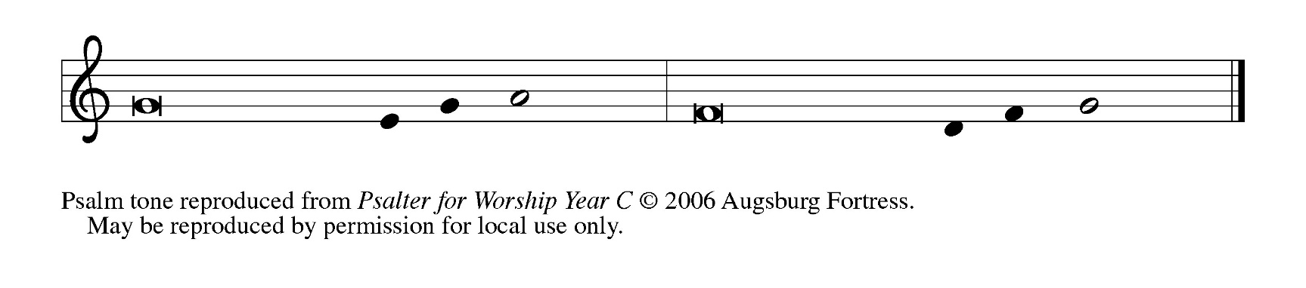
Sung responsively. Congregation chanting the bold portion

1 To | you, O Lord,
I lift | up my soul.
2 My God, I put my trust in you; let me not be | put to shame, nor let my enemies triumph | over me.
3 Let none who look to you be | put to shame;
rather let those be put to shame | who are treacherous.
4 Show me your | ways, O Lord,
and teach | me your paths.
5 Lead me in your | truth and teach me,
for you are the God of my salvation; in you have I trusted all | the day long.
6 Remember, O Lord, your compas- | sion and love,
for they are from | everlasting.
7 Remember not the sins of my youth and | my transgressions;
remember me according to your steadfast love and for the sake of your good- | ness, O Lord.
8 You are gracious and up- | right, O Lord;
therefore you teach sinners | in your way.
9 You lead the low- | ly in justice
and teach the low- | ly your way.

The Second Reading is from Philippians 2:1-13

¹ If, then, there is any comfort in Christ, any consolation from love, any partnership in the Spirit, any tender affection and sympathy, ² make my joy complete: be of the same mind, having the same love, being in full accord and of one mind. ³ Do nothing from selfish ambition or empty conceit, but in humility regard others as better than yourselves. ⁴ Let each of you look not to your own interests but to the interests of others. ⁵ Let the same mind be in you that was in Christ Jesus,⁶ who, though he existed in the form of God, did not regard equality with God as something to be grasped,⁷ but emptied himself, taking the form of a slave,
assuming human likeness. And being found in appearance as a human,⁸ he humbled himself and became obedient to the point of death—even death on a cross.⁹ Therefore God exalted him even more highly and gave him the name that is above every other name,¹⁰ so that at the name given to Jesus every knee should bend, in heaven and on earth and under the earth,¹¹ and every tongue should confess that Jesus Christ is Lord, to the glory of God the Father.¹² Therefore, my beloved, just as you have always obeyed me, not only in my presence but much more now in my absence, work on your own salvation with fear and trembling, ¹³ for it is God who is at work in you, enabling you both to will and to work for his good pleasure.

L: The word of the Lord.
C: Thanks be to God

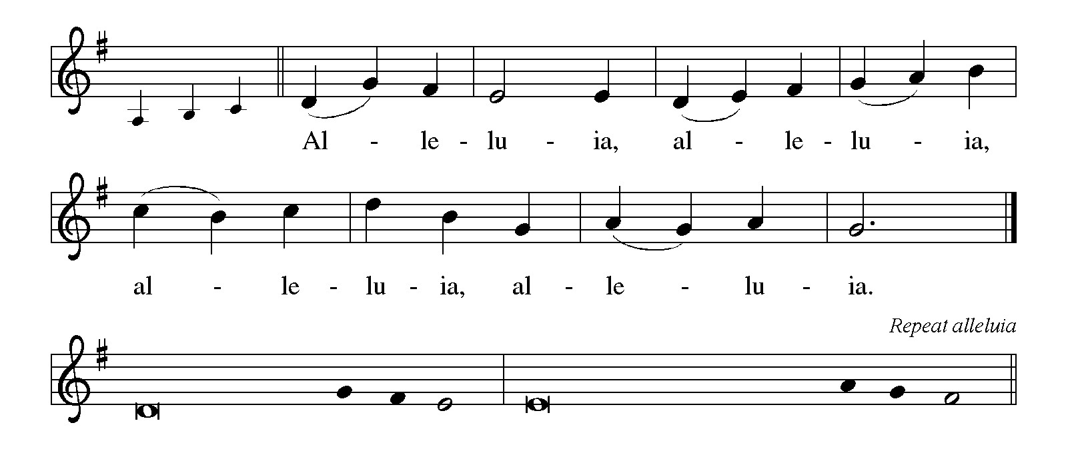
Lord, to whom | shall we go? * You have the words of | eternal life.

Holy Gospel and Response : Matthew 21:23-32

P: The holy gospel according to Matthew the 21st chapter
C: Glory to you, O Lord.

²³ When [Jesus] entered the temple, the chief priests and the elders of the people came to him as he was teaching and said, “By what authority are you doing these things, and who gave you this authority?” ²⁴ Jesus said to them, “I will also ask you one question; if you tell me the answer, then I will also tell you by what authority I do these things. ²⁵ Did the baptism of John come from heaven, or was it of human origin?” And they argued with one another, “If we say, ‘From heaven,’ he will say to us, ‘Why, then, did you not believe him?’ ²⁶ But if we say, ‘Of human origin,’ we are afraid of the crowd, for all regard John as a prophet.” ²⁷ So they answered Jesus, “We do not know.” And he said to them, “Neither will I tell you by what authority I am doing these things.
²⁸ “What do you think? A man had two sons; he went to the first and said, ‘Son, go and work in the vineyard today.’ ²⁹ He answered, ‘I will not,’ but later he changed his mind and went. ³⁰ The father went to the second and said the same, and he answered, ‘I go, sir,’ but he did not go.

³¹ Which of the two did the will of his father?” They said, “The first.” Jesus said to them, “Truly I tell you, the tax collectors and the prostitutes are going into the kingdom of God ahead of you. ³² For John came to you in the way of righteousness, and you did not believe him, but the tax collectors and the prostitutes believed him, and even after you saw it you did not change your minds and believe him.”

P: The gospel of the Lord.
C: Praise to you, O Christ.

Please Be Seated

Children’s Message

Sermon Pastor Larry Novak

Please Stand on the last verse of the Hymn of the Day
Hymn of the Day ELW #772 “Oh, That the Lord Would Guide My Ways”

+ + + OUR RESPONSE + + +

Apostles Creed

A: Let us confess together our faith using the words of the Apostle’s Creed.

C: I believe in God, the Father almighty,
creator of heaven and earth.

I believe in Jesus Christ, God’s only Son, our Lord,
who was conceived by the Holy Spirit,
born of the virgin Mary,
suffered under Pontius Pilate,
was crucified, died, and was buried;
he descended to the dead.*
On the third day he rose again;
he ascended into heaven,
he is seated at the right hand of the Father,
and he will come to judge the living and the dead.

I believe in the Holy Spirit,
the holy catholic church,
the communion of saints,
the forgiveness of sins,
the resurrection of the body,
and the life everlasting. Amen.

Prayer Concerns
Health issues:
Upcoming Surgery:
Recovering from Surgery:
Entered the Church Triumphant:

Prayers of the Church
A: Reminded of God’s gracious and abundant love, we offer our prayers, confident that God hears us.

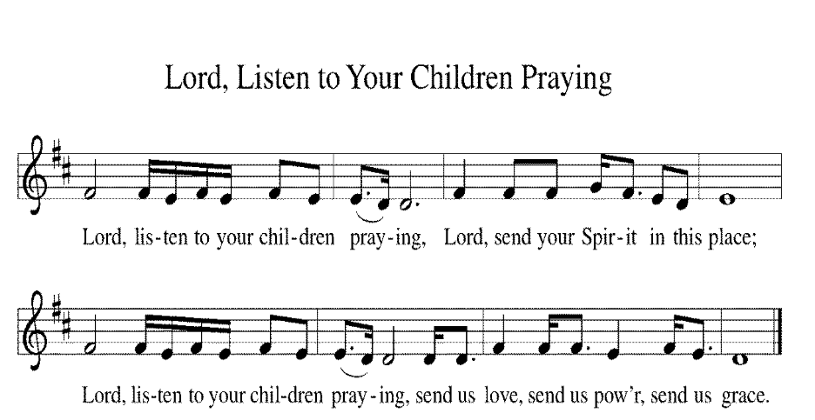

A: Center your church in humility as we strive to follow in your way. Help us listen to the cries of those who have been unfairly hurt by the church and dare to name difficult truths. Show all your love. Hear us, O God.
C: Your mercy is great.

A: You call us to care for your creation. Lead us into your promise of a better world through sustainable practices and respect for your handiwork. Hear us, O God.
C: Your mercy is great.

A: Inspire all in positions of authority to act honorably. Remind them of their call to use their authority for the sake of the common good. Give them the gift of humility. Hear us, O God.
C: Your mercy is great.

A: Comfort those who come before you in fear and trembling. Calm troubled hearts with your forgiveness. Help all those in need especially those we name either aloud or in silence (wait 7 seconds). Grant us your salvation. Hear us, O God.
C: Your mercy is great.

A: Change this congregation’s heart when we say no to your call. Open us to courageous learning and service in our community, especially in new or challenging places. Hear us, O God.
C: Your mercy is great.

A: Your steadfast love holds all the saints who have finished their work and are at rest. As we grieve, remind us of your mercy so we may also give thanks. Hear us, O God.
C: Your mercy is great.

P: Grant the prayers we have offered, what we have forgotten to ask, and whatever else you see that we need. We ask this in Jesus’ name.
C: Amen.

Peace
P: The peace of Christ be with you always.
C: And also with you.

Please share the peace with one another

Please Remain Standing
Offertory Response “Create in My a Clean Heart”

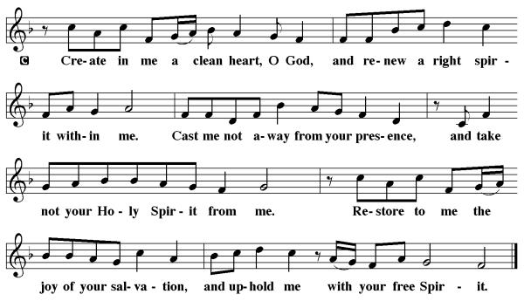

Offertory Prayer

A: Let us pray. God of creation,
you send rain and the earth springs forth abundantly.
All blessings are from you;
make us generous with what we have.
Use our gifts, our abilities, and our hearts
in service to you and in love to our neighbors,
today and always.
C: Amen.

The Great Thanksgiving

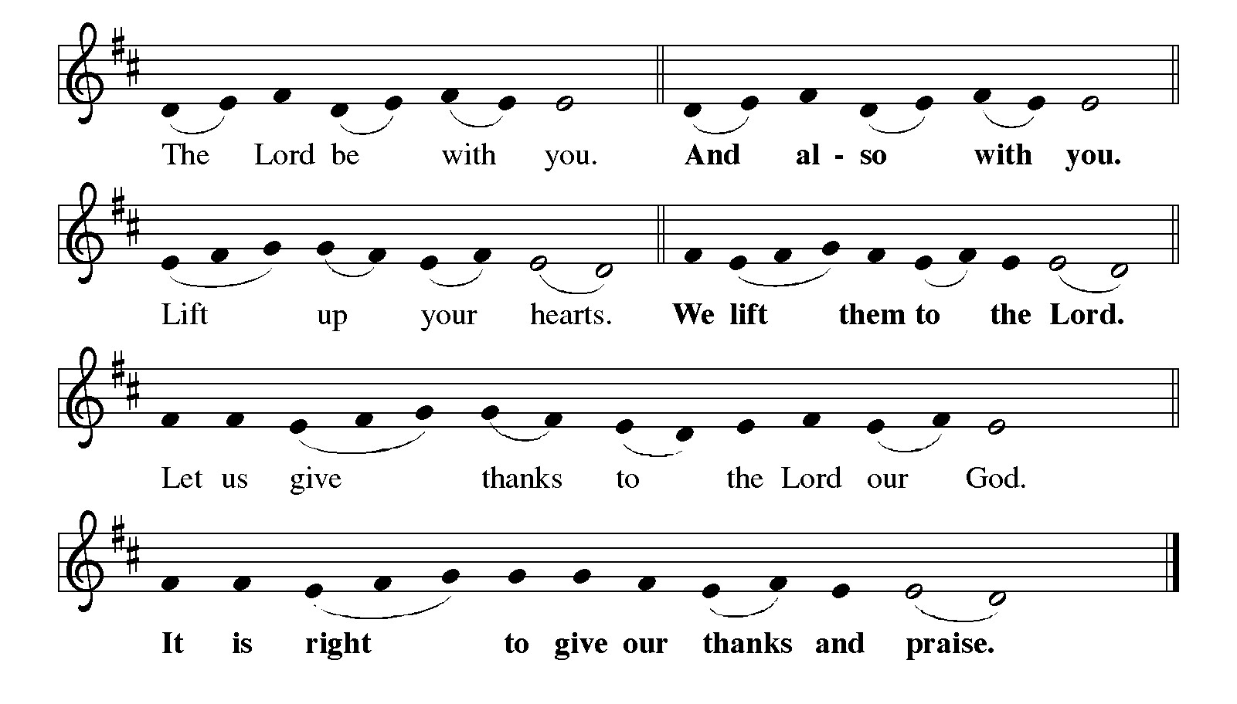

Eucharist prayer

It is indeed right, our duty and our joy,
that we should at all times and in all places
give thanks and praise to you, almighty and merciful God,
through our Savior Jesus Christ;
who on this day overcame death and the grave,
and by his glorious resurrection opened to us the way of everlasting life.
And so, with all the choirs of angels,
with the church on earth and the hosts of heaven,
we praise your name and join their unending hymn:

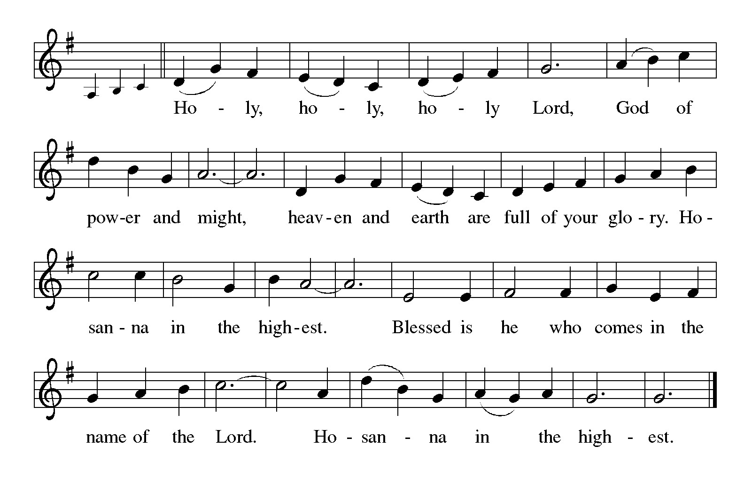

P: You are indeed holy, almighty and merciful God.
You are most holy,
and great is the majesty of your glory.

You so loved the world that you gave your only Son,
so that everyone who believes in him may not perish
but have eternal life.

We give you thanks for his coming into the world
to fulfill for us your holy will
and to accomplish all things for our salvation.

In the night in which he was betrayed,
our Lord Jesus took bread, and gave thanks;
broke it, and gave it to his disciples, saying:
Take and eat; this is my body, given for you.
Do this for the remembrance of me.

Again, after supper, he took the cup, gave thanks,
and gave it for all to drink, saying:
This cup is the new covenant in my blood,
shed for you and for all people for the forgiveness of sin.
Do this for the remembrance of me.

For as often as we eat of this bread and drink from this cup,
we proclaim the Lord’s death until he comes.

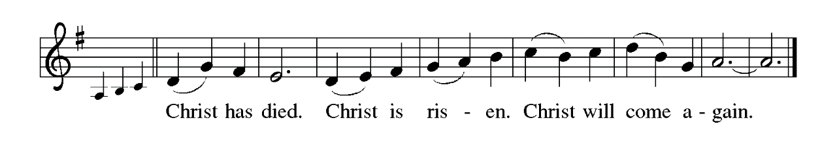
Remembering, therefore, his salutary command,
his life-giving passion and death, his glorious resurrection and ascension,
and the promise of his coming again,
we give thanks to you, O Lord God Almighty,
not as we ought but as we are able;
we ask you mercifully to accept our praise and thanksgiving
and with your Word and Holy Spirit to bless us, your servants,
and these your own gifts of bread and wine,
so that we and all who share in the body and blood of Christ
may be filled with heavenly blessing and grace,
and, receiving the forgiveness of sin,
may be formed to live as your holy people
and be given our inheritance with all your saints.

To you, O God, Father, Son, and Holy Spirit,
be all honor and glory in your holy church, now and forever.

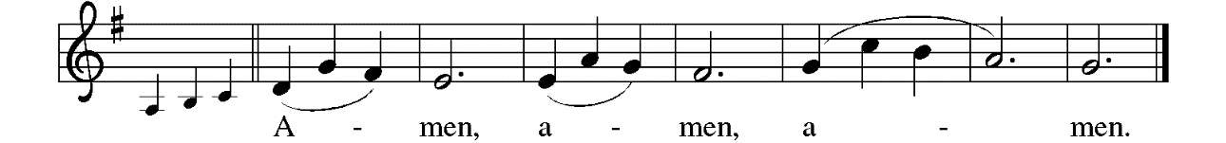

Lord’s Prayer
P: Gathered into one by the Holy Spirit, let us pray as Jesus taught us.
C: Our Father, who art in heaven, hallowed be thy name, thy kingdom come, thy will be done, on earth as it is in heaven. Give us this day our daily bread; and forgive us our trespasses, as we forgive those who trespass against us; and lead us not into temptation, but deliver us from evil. For thine is the kingdom, and the power, and the glory, forever and ever. Amen

P: All means all and the gifts of God are free. Come and receive a foretaste of the feast to come.

Lamb of God

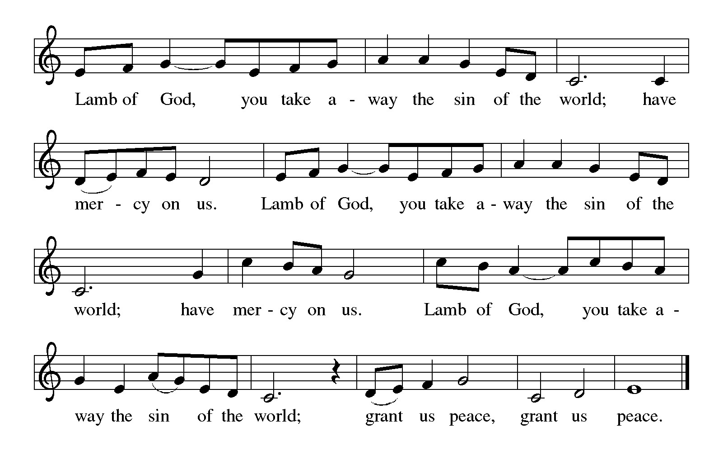

Holy Communion
As Lutheran Christians, we believe the body and blood of Jesus are truly present in the form of bread and wine. All who believe and have been baptized are invited to partake of the sacrament of Holy Communion.
All others are invited to come forward for a blessing.
To receive communion, please come forward at the direction of the ushers. Pastor will distribute the bread. Gluten free wafers are in the small dish.
Take a cup from the tall set of trays if you wish to have wine or from the short stack if you wish to have the grape juice.
After giving thanks, return to your pew by the side aisles.
(If you want to take communion in your pew, please let the ushers know)

During Distribution
“Prayer” by Mozart
“When There's Love at Home” by McNaughton

Communion Blessing
P: The body and blood of our Lord Jesus Christ strengthen and keep you in his grace.
C: Amen.

Post Communion Canticle

Post Communion Prayer

A: Let us pray. Sustaining God,
with this bread and cup,
you nourish us with mercy and abundant life.
By your Spirit, send us from this table to serve a needy world.
Make us living signs of your liberation, healing, and love,
following the way of Jesus, in whose name we pray.
C: Amen.

+ + + WE ARE SENT FORTH + + +

Blessing
P: The God of love
draw you into full accord and one mind,
in the body of Christ Jesus.
C: Amen.
The God of hope
grant you strength and joy in all circumstances
through the interceding of the Spirit.
C: Amen.
The God of grace
☩ bless you now and forever.
C: Amen.

Sending Hymn ELW #815 “I Want to Walk as a Child of the Light”

Dismissal
A: Go out in joy. Be led forth in peace.
C: Thanks be to God.

Postlude “With Peace in My Soul” by Paxton

From Sundays and Seasons.com. Copyright 2015 Augsburg Fortress. All rights reserved.
Reprinted by permission under Augsburg Fortress Liturgies Annual License #20386.
New Revised Standard Version Bible, copyright 1989, Division of Christian Education of the National Council of the Churches of Christ in the United States of America. Used by permission. All rights reserved.
Serving in Worship Today
Worship Assistant: Lottie Bodin
Communion Assistant: Ray Swisher
Usher: Dave Comstock
Reader: Beth Harman
Greeter: Brian Hogan Family
Acolyte: Brooks Bodin
Altar Guild: Stephanie Oaks
Communion Bread: Pastor Larry Novak

Serving in Worship 10/4
Worship Assistant: Chris McKenrick
Communion Assistant: Sue Neer
Usher: Ray Swisher
Reader: Bodin
Greeter: Joann Kern
Acolyte:
Altar Guild: Stephanie Oaks
Communion Bread: Sue Neer

Calender of Events September 28th – October 4th

Monday, Sept. 28:
10:00am Staff Meeting
7:00pm Worship

Tuesday, Sept. 29:
9:00am Quilters

Wednesday, Sept. 30:
3:00pm NA
3:00pm Pastor’s Meeting

Thursday, Oct. 1:
Pastor out – Trinity Days Seminar
3:00pm NA
7:00pm Choir
8:00pm Bells

Friday, Oct. 2:
Office Closed

Saturday, Oct. 3:
Office Closed

Sunday, Oct. 4:
8:45am Adult Class
9:00am Fellowship
10:00am Communion Service


Suggested Food Items for September

- mac n cheese
- canned fruit

